SKYLINK TRAVEL ANALYSIS REPORT

A Comprehensive Analysis of Revenue Drivers, Customer Segments, and Booking Performance
Prepared by: Samuel Muiruri
Tools Used: Power BI, Power Query, DAX
Analysis Approach: ELT (Extract, Load, Transform)
Date: June 2026

Table of Contents
- Executive Summary
- Business Problem
- Dataset Overview
- Data Preparation (ELT)
- Data Modeling
- Analysis & Findings
  - Time Intelligence
  - Routes & Destinations
  - Traveler Segments
  - Airline Performance
  - Booking Channel Performance
- Key Business Recommendations
- Limitations
- Conclusion

1. Executive Summary
Skylink Travel sought to better understand the factors influencing revenue generation, customer booking behavior, airline performance, and travel demand. The objective was to identify opportunities for revenue growth, optimize strategic partnerships, and support data-driven decision-making.
The analysis revealed that domestic travel serves as the company's primary revenue engine due to its high booking volume, while international travel generates significantly higher revenue per booking despite representing less than 9% of total bookings. Business travel emerged as the dominant traveler segment, airline revenue was concentrated among four major U.S. carriers, and booking channels demonstrated balanced performance with no single platform dominating customer acquisition.
The findings suggest that Skylink can improve profitability by expanding high-value international demand, strengthening business traveler loyalty, promoting leisure travel during off-peak periods, and improving customer data collection for future retention analysis.

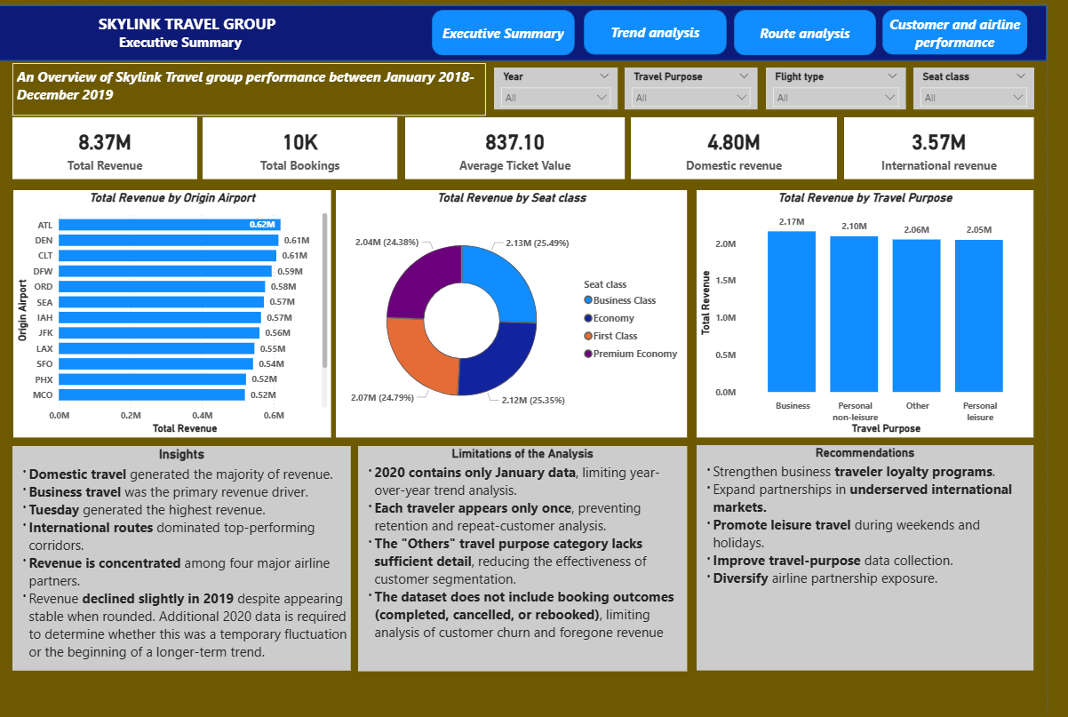

Figure 1: Executive Dashboard
2. Business Problem
The objective of this project was to answer the following business questions:
- Which destinations generate the highest revenue?
- Which traveler segments contribute most to revenue?
- Which airline partners drive profitability?
- Which booking channels perform best?
- How does travel demand vary over time?
- What opportunities exist for increasing future revenue?

3. Dataset Overview
The dataset contained approximately 10,000 travel bookings across multiple years and included information on:
- Booking dates
- Travel dates
- Airlines
- Airports
- Countries
- Seat class
- Booking agency
- Travel purpose
- Ticket revenue
- Traveler names
Initial Data Quality Assessment
Several issues were identified:
- Missing Return Dates
- Missing Return Airports
- Minor missing values in Destination State
- Airline naming inconsistencies
- Excel serial dates
- Separate first and last name columns
These issues were resolved before beginning the analysis.

4. Data Preparation (ELT)
Power Query was used to clean and standardize the dataset before loading it into the Power BI model.
The following transformations were performed:
Data Cleaning
- Standardized airline names using a mapping table.
- Converted Excel serial numbers into proper dates.
- Merged First Name and Last Name into a single Traveler Name field.
- Removed leading/trailing spaces.
- Standardized text formatting.
- Verified there were no duplicate or negative revenue values.
- Investigated missing values.
New Columns Created
- Route (Origin Airport → Destination Airport)
- Flight Type (Domestic vs International)
Date Table
A dedicated Date Dimension was created to support:
- Year analysis
- Month analysis
- Weekday analysis
- Seasonal analysis

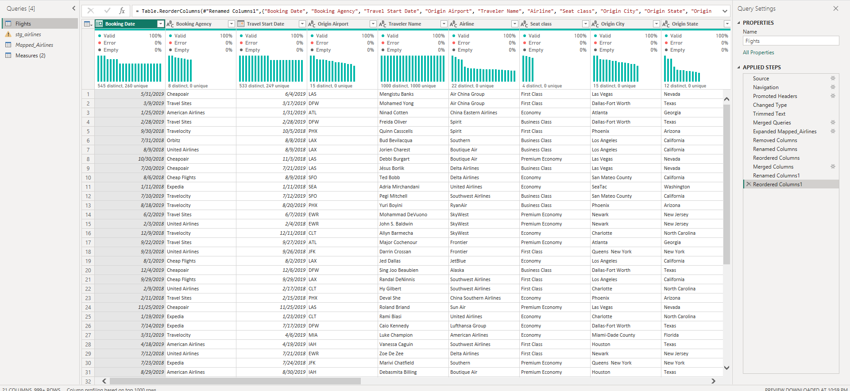Figure 2: Power Query showing data cleaning and transformations

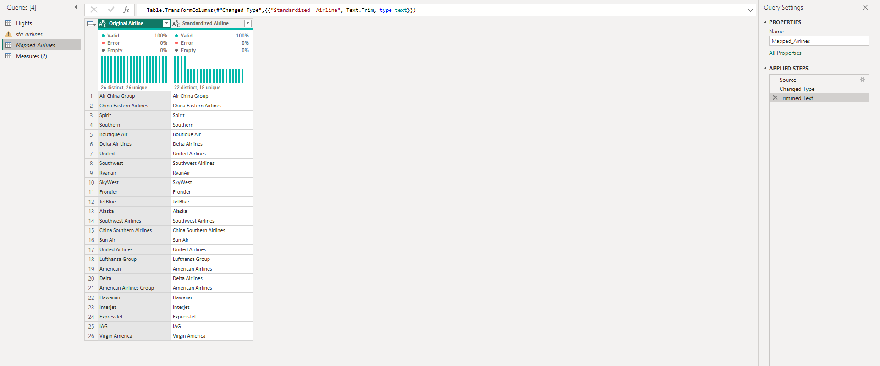
Figure 3: Airline Mapping Table

5. Data Modeling
A star schema was implemented to improve analytical performance.
The model included:
- Fact Table (Flights)
- Date Dimension
- Airline Mapping Table
Several DAX measures were created, including:
- Total Revenue
- Total Bookings
- Average Ticket Value
- Revenue Share %
- Domestic Revenue
- International Revenue
- Revenue per Traveler

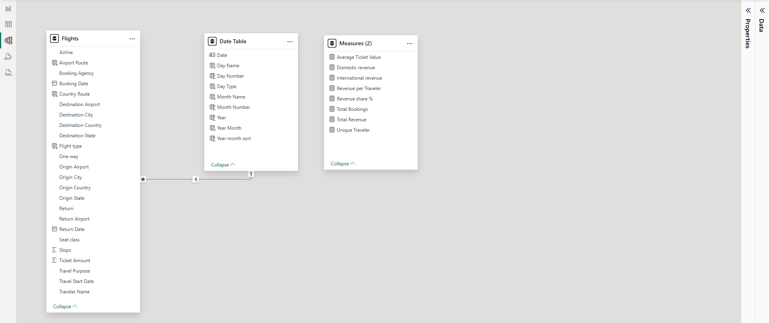
Figure 4: Power BI Data Model

6. Analysis & Findings
6.1 Time Intelligence Analysis
The time analysis revealed seasonal fluctuations in both revenue and bookings.
Key Findings
- Revenue peaked during March, June, and October.
- Tuesday generated the highest revenue.
- Sunday generated the lowest revenue.
- A slight decline in revenue was observed in 2019.
- Since only January 2020 data was available, it was not possible to determine whether the decline represented a long-term trend.
Recommendations
- Introduce weekend promotions to stimulate leisure travel.
- Obtain complete 2020 data to validate revenue trends.

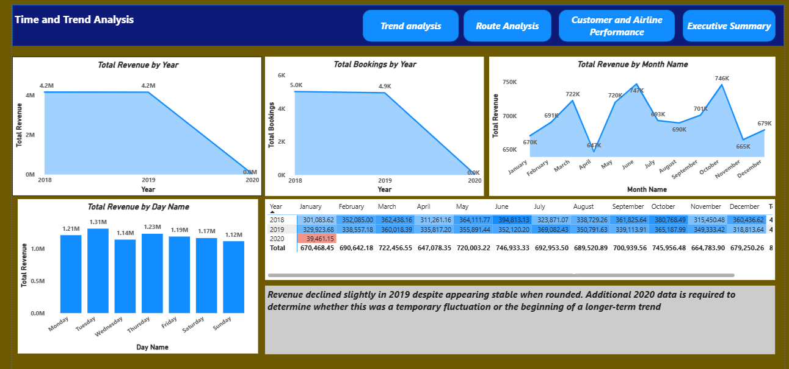
Figure 5: Time Intelligence Dashboard

6.2 Routes & Destination Analysis
Domestic flights accounted for:
- 91.05% of bookings
- 57.37% of revenue
International flights accounted for:
- 8.95% of bookings
- 42.63% of revenue
This indicates that international bookings generate substantially higher revenue per booking.
Additional Findings
- Domestic travel generated the largest share of total revenue.
- International airport routes dominated the highest-revenue corridors.
- The U.S. generated the highest destination revenue.
- Europe, Asia, and Australia represented the strongest international markets.
Recommendations
- Expand high-performing international routes.
- Explore partnerships in underrepresented regions such as Africa and South America.
- Improve connection flight efficiency on high-value international corridors.

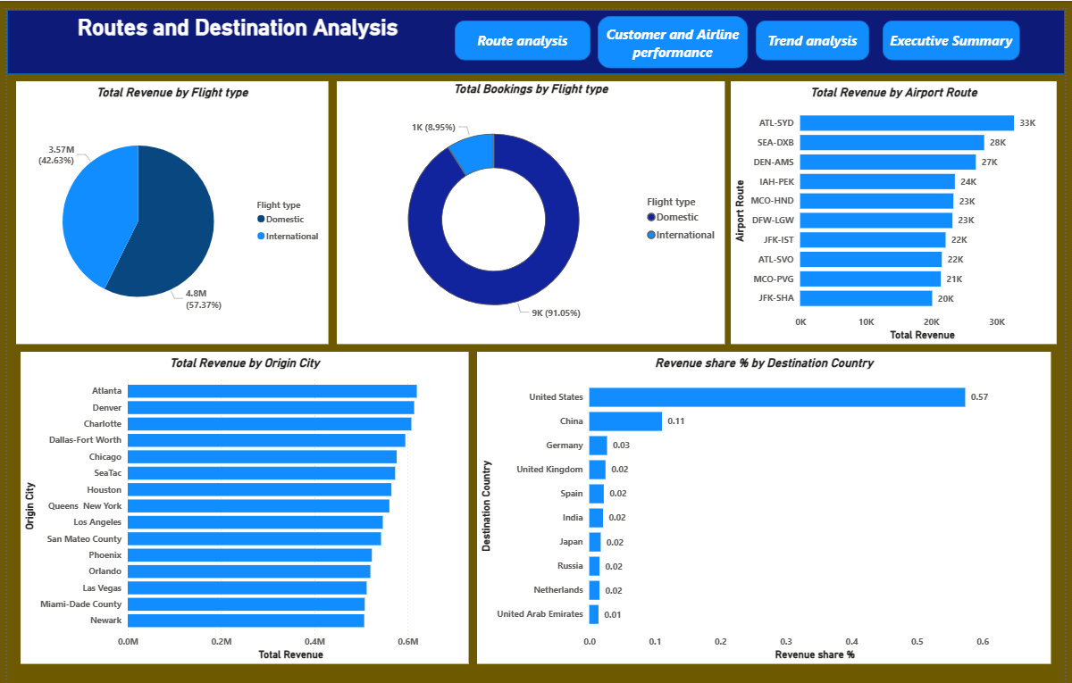
Figure 6: Routes & Destination Dashboard

6.3 Traveler Segment Analysis
Travel Purpose
Business travel generated the highest revenue, followed by:
- Personal non-Leisure
- Others
- Personal Leisure
Business travel remains the company's strongest customer segment.
Leisure travel represents a significant growth opportunity.
Seat Class
Business Class generated the highest revenue.
However, revenue differences between seat classes were relatively small, suggesting a balanced customer mix.
Recommendations
- Strengthen loyalty benefits for business travelers.
- Review premium class differentiation.
- Evaluate seat allocation across aircraft.

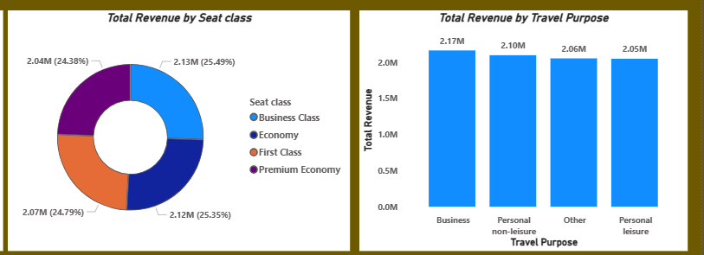
Figure 7: Traveler Segments Dashboard

6.4 Airline Performance
Four airlines dominated both revenue and booking volume:
- Southwest
- American
- Delta
- United
A significant drop in performance occurred after the fourth-ranked airline.
Interestingly, airlines with the highest Average Ticket Value differed from those generating the highest revenue.
This indicates that some airlines compete through passenger volume while others generate value through higher-priced bookings.
Recommendations
- Strengthen partnerships with high-performing airlines.
- Diversify airline partnerships to reduce concentration risk.
- Investigate factors contributing to higher average ticket values.

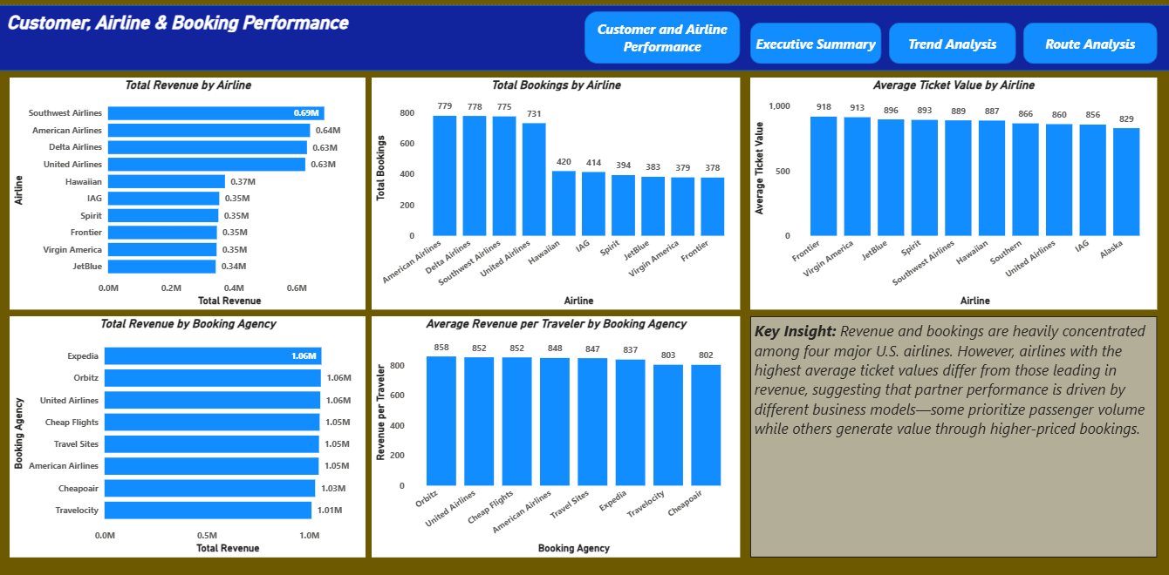
Figure 8: Airline Performance Dashboard

6.5 Booking Channel Performance
Multiple booking platforms performed consistently across:
- Revenue
- Unique Travelers
- Revenue per Traveler
Expedia ranked first in revenue and second in unique travelers but did not dominate the market.
Direct bookings through airline websites such as United and American were also observed.
Recommendations
- Maintain a diversified booking channel strategy.
- Strengthen direct booking capabilities.
- Evaluate successful practices from top-performing booking platforms.


Figure 9: Booking Channel Dashboard

7. Key Business Recommendations
Based on the findings, the following strategic initiatives are recommended:
Revenue Growth
- Expand profitable international routes.
- Increase international booking volume while maintaining high booking values.
- Promote leisure travel during weekends and holidays.
Customer Strategy
- Strengthen loyalty programs for business travelers.
- Improve premium cabin differentiation.
- Collect more detailed travel purpose information.
Partnerships
- Strengthen relationships with leading airline partners.
- Expand partnerships in underserved international markets.
- Maintain a diversified booking channel strategy.
Data Strategy
- Introduce Customer IDs to enable retention analysis.
- Capture booking status (Completed, Cancelled, Rebooked).
- Improve travel purpose categorization.

8. Limitations
Several limitations should be considered when interpreting the findings:
- The dataset contained only January data for 2020, limiting year-over-year trend analysis.
- Each traveler appeared only once, preventing customer retention and loyalty analysis.
- The "Others" travel purpose category reduced segmentation quality.
- Booking outcomes (completed, cancelled, or rebooked) were unavailable.
- The dataset did not include customer demographics such as age or income.

9. Conclusion
This analysis demonstrated how business intelligence techniques can be applied to transform raw travel booking data into actionable insights. By combining data cleaning, modeling, visualization, and strategic interpretation, the project identified key revenue drivers, traveler behaviors, airline partnership opportunities, and areas for future business growth.
The findings suggest that while Skylink benefits from a strong domestic customer base, significant opportunities exist to expand high-value international travel, optimize airline partnerships, encourage leisure demand, and improve data collection practices. These recommendations provide a foundation for more informed decision-making and long-term revenue growth.

